Link to the pathway description:

<http://metacyc.org/META/NEW-IMAGE?type=PATHWAY&object=PWY-6051&detail-level=1>

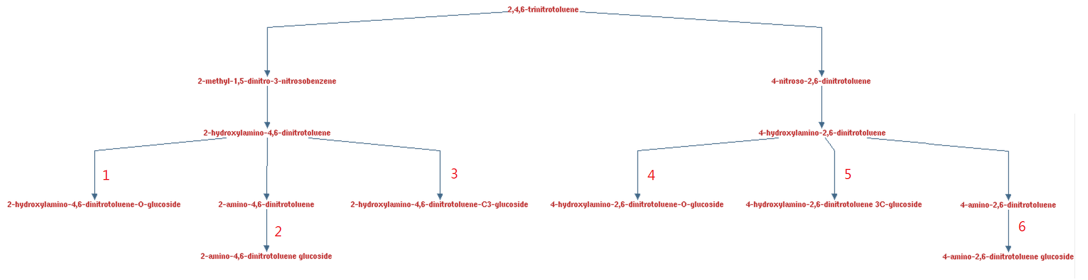

Highlighted reactions:

1. <http://metacyc.org/META/NEW-IMAGE?type=REACTION-IN-PATHWAY&object=RXN-9743&detail-level=1>
2. <http://metacyc.org/META/NEW-IMAGE?type=REACTION-IN-PATHWAY&object=RXN-9745&detail-level=1>
3. <http://metacyc.org/META/NEW-IMAGE?type=REACTION-IN-PATHWAY&object=RXN-9752&detail-level=1>
4. <http://metacyc.org/META/NEW-IMAGE?type=REACTION-IN-PATHWAY&object=RXN-9748&detail-level=1>
5. <http://metacyc.org/META/NEW-IMAGE?type=REACTION-IN-PATHWAY&object=RXN-9749&detail-level=1>
6. <http://metacyc.org/META/NEW-IMAGE?type=REACTION-IN-PATHWAY&object=RXN-9751&detail-level=1>

All of those reactions are catalyzed by the same family of enzymes (EC 2.4.1 in Metacyc database): <http://metacyc.org/META/NEW-IMAGE?type=EC-NUMBER&object=EC-2.4.1&detail-level=1>

The frequency of its occurrence in the annotation list was 25/3447 = 0.73% (ranked at 17th) However if we include all the enzyme starting with EC-2.4.1 (e.g. EC-2.4.1.1, EC-2.4.1.15 etc. they are instances of the enzyme class EC-2.4.1), the frequency goes up to (25+34)/3447 = 1.71%

(As a reference, the most abundant is 3-oxoacyl-[acyl-carrier-protein] reductase (EC-1.1.1.100), with frequency of occurrence 103/3447 = 2.99%)

It turns out all the reactions that are not highlighted are catalyzed by the same family of enzyme too, which is EC-1.7.99.- (two instances EC-1.7.99.4 and EC-1.7.99.7), the frequency of occurrence is 4/3447 = 0.12% (very low)